Nine Acres Primary School
Geography Curriculum
Geograhy INTENT:
Our inclusive Geography curriculum aims to inspire young geographers to explore the world and become passionate about shaping its future. At Nine Acres, we provide children with a deep understanding of where they live and the wider world around them. We aim to equip our pupils with the knowledge and skills they need to become articulate and persuasive global citizens. They will have a keen curiosity and fascination about the world and its people, which will remain with them for the rest of their lives. Our young geographers can positively influence the world because of their learning at Nine Acres.

Nine Acres Primary School – Curriculum Overview: Geography
 | Autumn 1 | Autumn 2 | Spring 1 | Spring 2 | Summer 1 | Summer 2
EYFS | All About Me | Once Upton a Time - How can we represent settings in traditional tales? | Around the World - How are other countries different to where I live? | Superheroes - How can our actions impact the environment? | Growing - How does the environment affect growth? Where does our food come from? | Island Life - Why do people want to come to the Isle of Wight?
Year 1 |  | Where in the world do I live? |  | Fieldwork - My local park  Fieldwork: Our school environment
Year 2 |  | What are the similarities and differences between my town and Tulum, Mexico? |  | Fieldwork - How can we record and measure different weather phenomena.
Year 3 |  | What are the key geographical features of the UK, and my region? |  | Fieldwork - What facilities are in my local area and how do people travel there?
Year 4 |  | Fieldwork - How can we record and measure weather phenomena? | What are the similarities and differences between my region and Campania, Italy? |  |  | Locality Unit -  Erosion on the IOW
Year 5 |  |  |  | Fieldwork - What are the features of my local river?  Fieldwork - What trees, plants and animals are in our local ecosystems? | What are the similarities and differences between my region and the Western United States?
Year 6 | What is the economic activity of the UK, and how sustainable is it? |  |  |  |  | Fieldwork - How can our school reduce its plastic waste?

Nine Acres Primary School – Vocabulary Progression EYFS
 | Autumn 1 | Autumn 2 | Spring 1 | Spring 2 | Summer 1 | Summer 2
EYFS | Map  Address  Isle of Wight Newport  Journey  Route  Island | Map  Setting  Journey  Route  Positional language (over, under, behind, in front of, next to) | Climate  Country  Desert  Rainforest  Volcano  Migration  Mountain  Landmark | Environment Recycle  Impact  Litter  Fieldwork | Environment Climate  Equator  Observation  Country  Farming | Island  Isle of Wight Tourism  Tourist  Coast  Travel

Medium Term Plan – EYFS Autumn 1
All about me
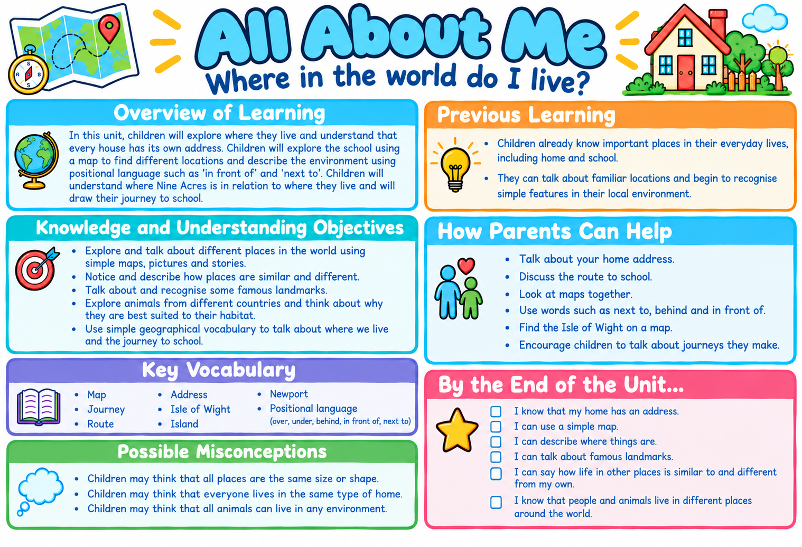

Medium Term Plan – EYFS Autumn 2
Once Upon a Time -
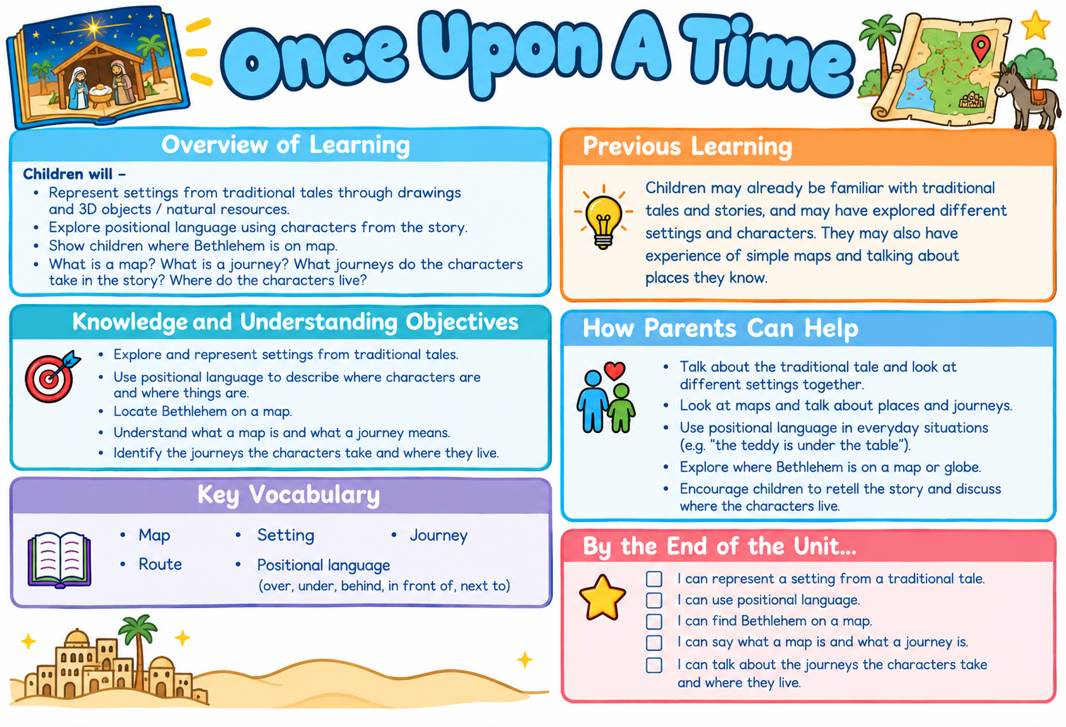

Medium Term Plan – EYFS Spring 1
Around the World
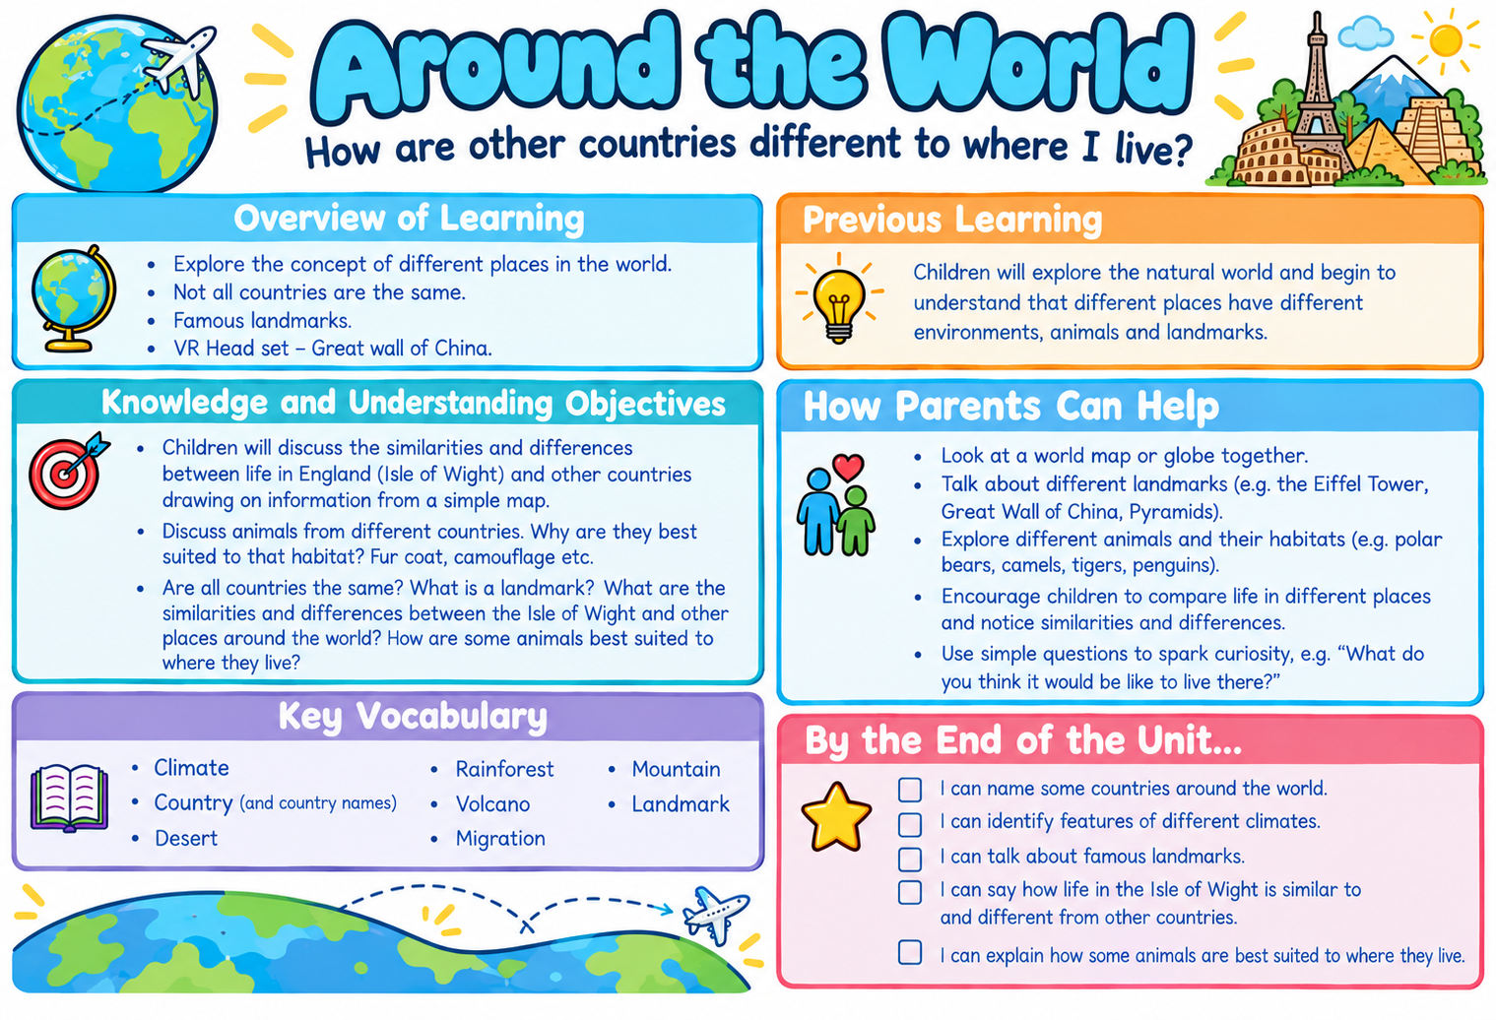

Medium Term Plan – EYFS Spring 2
Superheroes
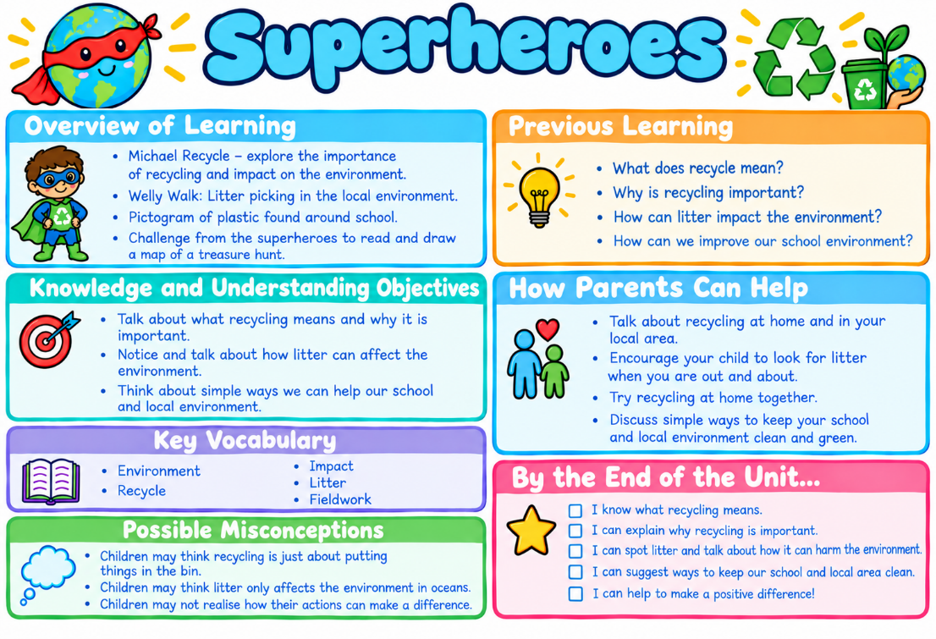

Medium Term Plan – EYFS Summer 1
Growing
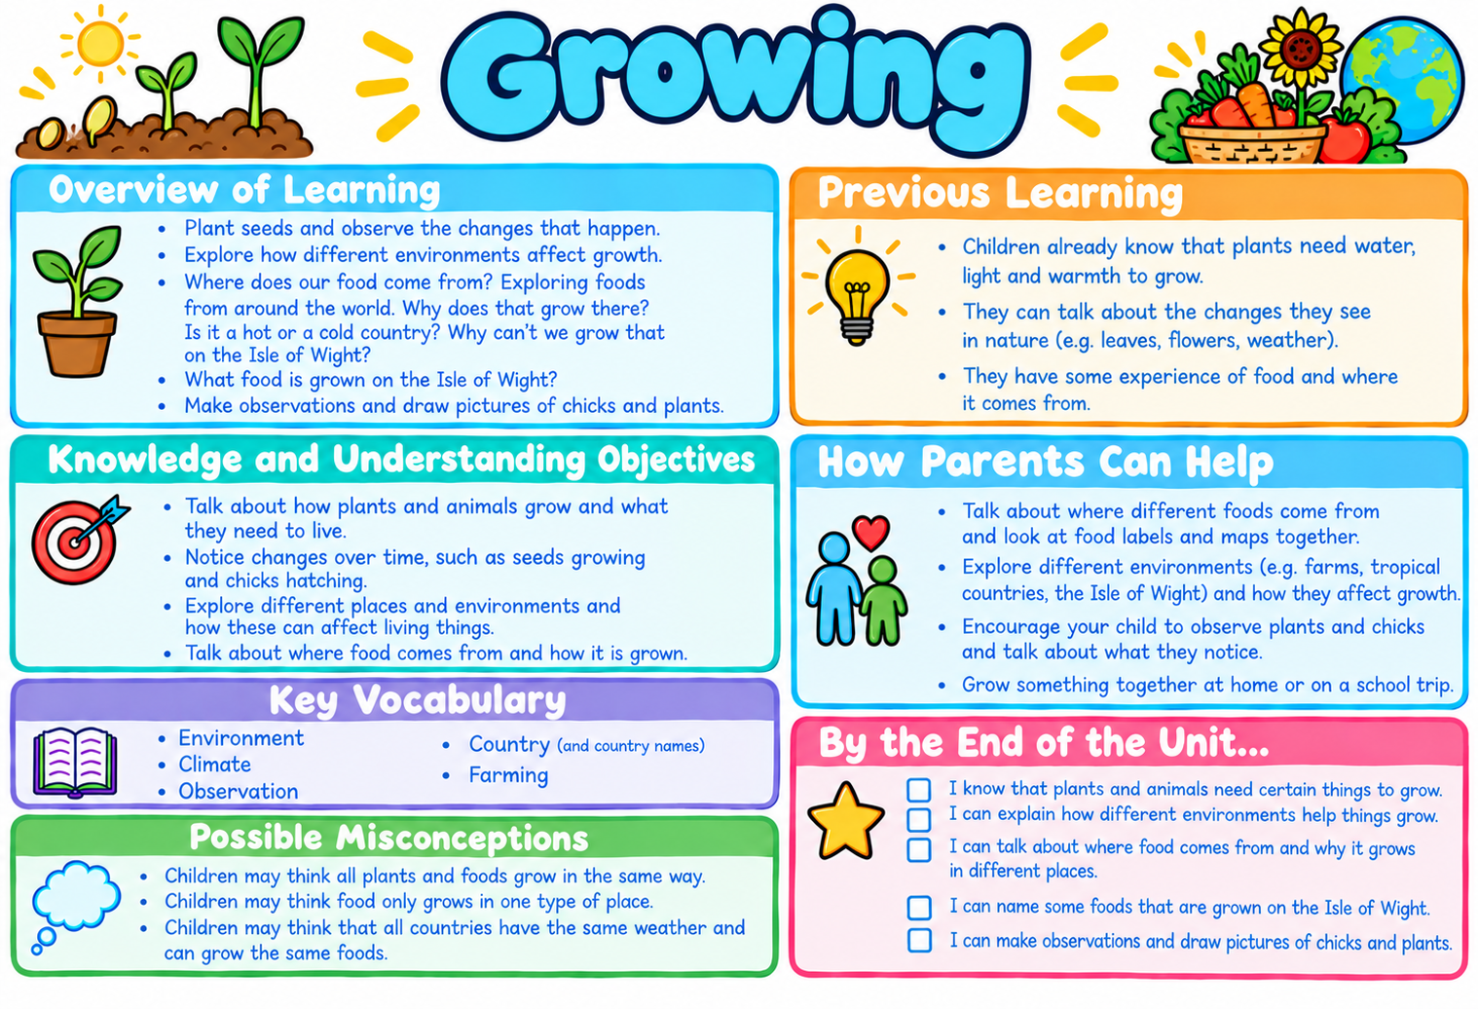

Medium Term Plan – EYFS Summer 2
Island Life
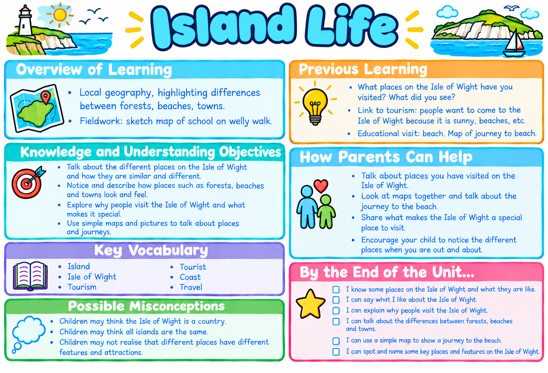

Nine Acres Primary School – Vocabulary Progression Year 1
 | Autumn 1 | Autumn 2 | Spring 1 | Spring 2 | Summer 1 | Summer 2
Year 1 |  | Atlas, aerial view, map, address, local area, physical feature, human feature. town, street, city, village, continents, globe, ocean, climate, seasons, temperature, weather, equator, North Pole, South Pole | Compass, directions, fieldwork, local area, map, route, aerial view, data, human feature, observe, physical feature, record, facility, present, map key, map symbol, plant life

Medium Term Plan – Year 1 Autumn 2
Where in the world do I live?
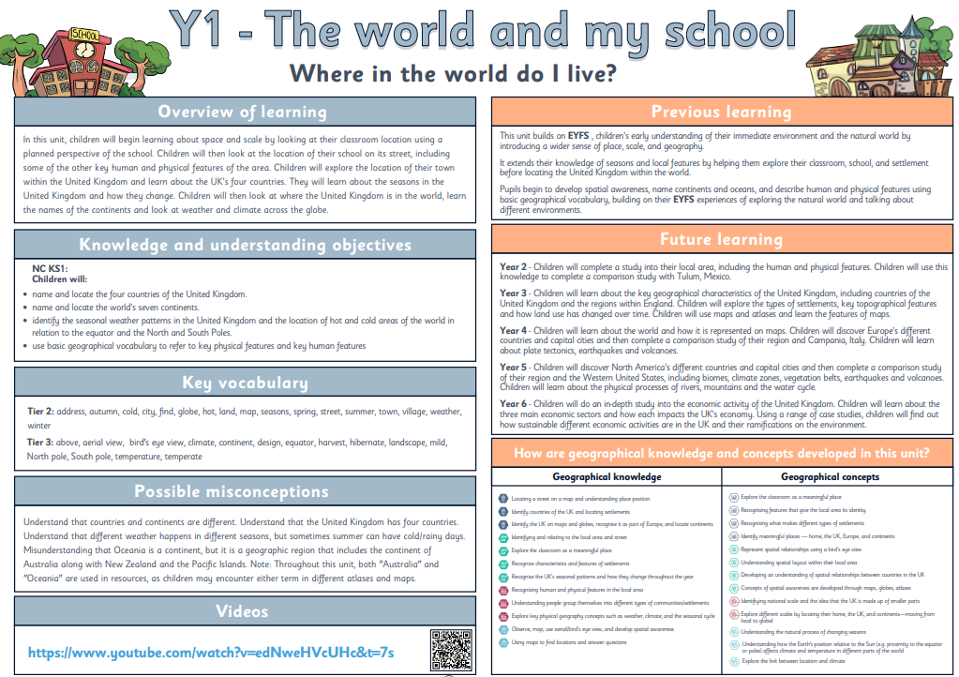

Medium Term Plan – Year 1 Spring 1
Fieldwork – My local park
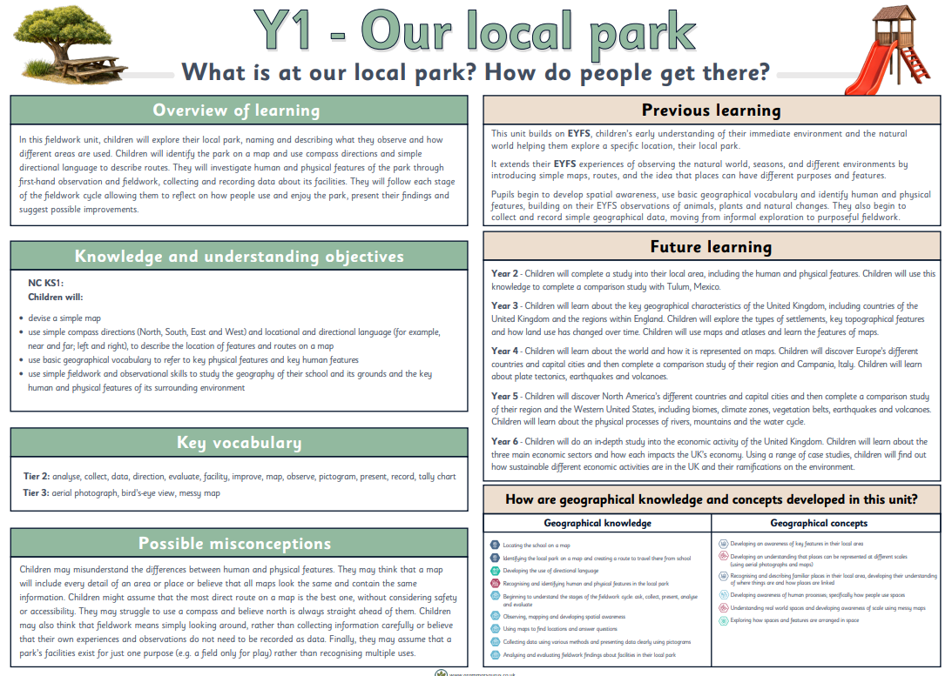

Medium Term Plan – Year 1 Spring 1
Fieldwork – Our school environment
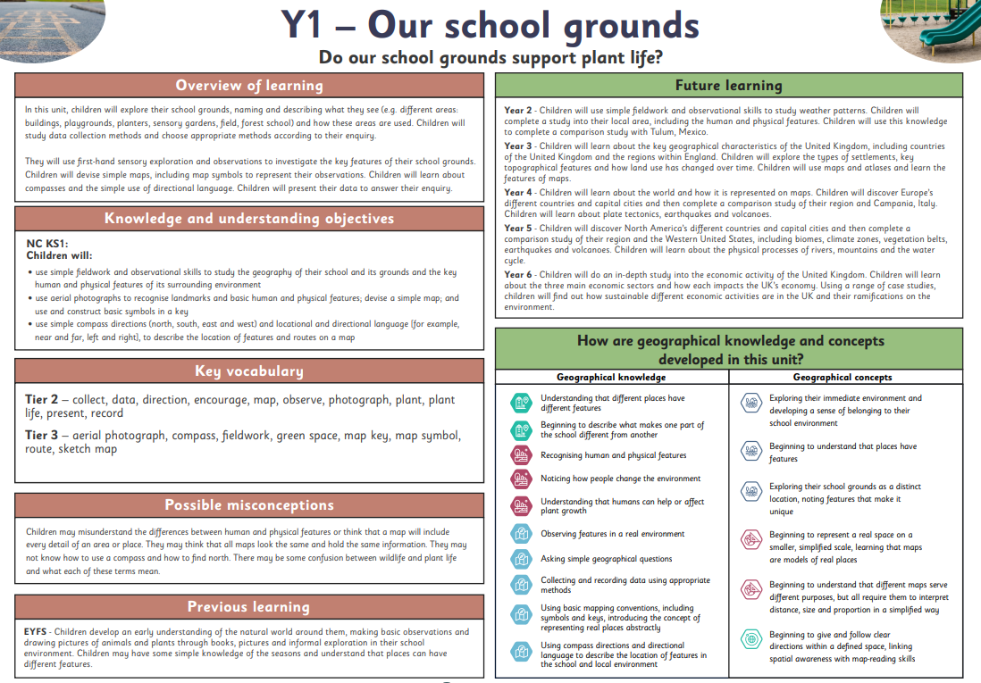
Nine Acres Primary School – Vocabulary Progression Year 2
 | Autumn 1 | Autumn 2 | Spring 1 | Spring 2 | Summer 1 | Summer 2
Year 2 |  | Atlas, continents, map, ocean, scale, symbols, equator, North Pole, oceans, season, South Pole, capital city, port, sea, human features, local area, physical features, town, village, landscapes, compare, cenote, coral reef, rainforest, mangroves, marsh |  | Weather, climate, climate zone, meteorologist, temperature, equator, poles, atmosphere, precipitation, forecast, symbol, fieldwork, observe, investigate, collaborate, monitor, record

Medium Term Plan – Year 2 Autumn 2 / Spring 1
What are the similarities and differences between my town and Tulum, Mexico?
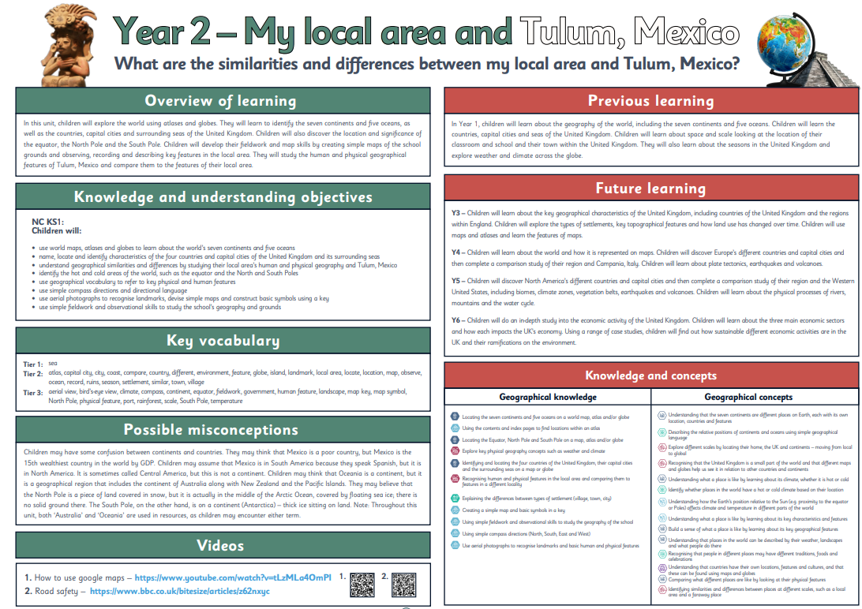
Medium Term Plan – Year 2 Spring 2
Fieldwork - How can we record and measure different weather phenomena?

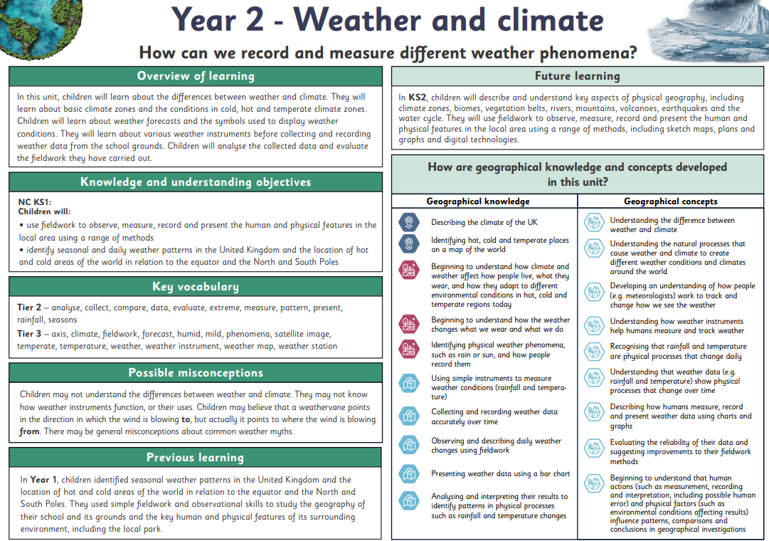
Nine Acres Primary School – Vocabulary Progression Year 3
 | Autumn 1 | Autumn 2 | Spring 1 | Spring 2 | Summer 1 | Summer 2
Year 3 |  | Aerial photograph. atlas, city, compass, map, region, settlement, village, town, city, country, rural, urban, human feature, landmark, office, house, harbour, port, farm, factory, shop, landscape, mountain range, coastline, valley, rock formation, topography, compass, cardinal directions, compass, key, Ordnance Survey, OS map, map symbols, green belt, population, elevation, topography, population, land use, region |  | Hamlet, land use, raw materials, rural, settlement, suburb, urban, city, county, commuters, population, town, village, fieldwork, analyse, bar chart, evaluate, line graph, tally chart

Medium Term Plan – Year 3 Autumn 2 / Spring 1
What are the key geographical features of the UK, and my region?
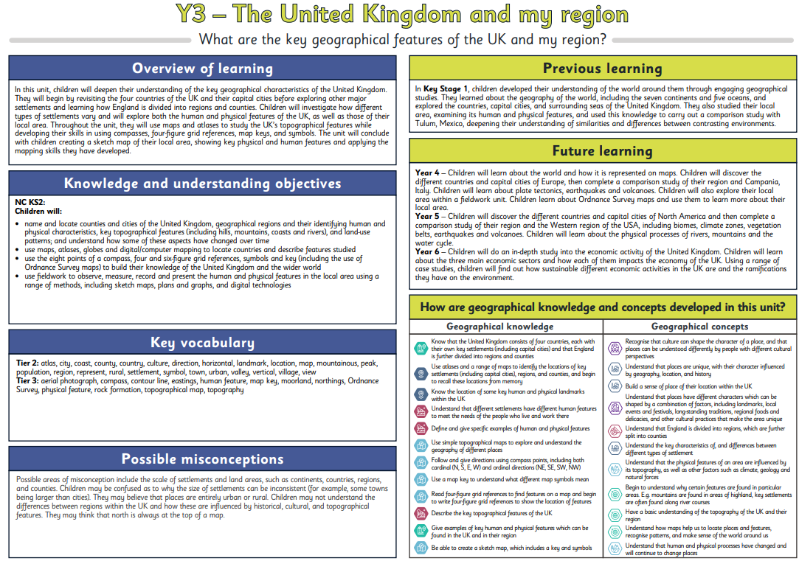

Medium Term Plan – Year 3 Spring 2
Fieldwork - What facilities are in my local area and how do people travel there?
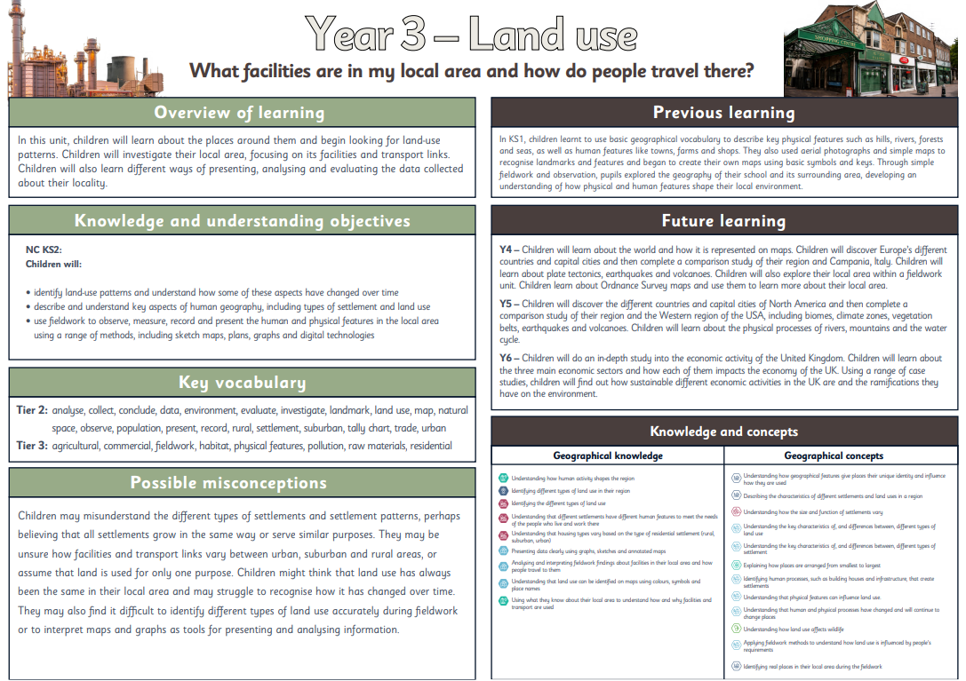
Nine Acres Primary School – Vocabulary Progression Year 4
 | Autumn 1 | Autumn 2 | Spring 1 | Spring 2 | Summer 1 | Summer 2
Year 4 |  | Weather, climate, climate zones, meteorologist, temperature, mild, temperate, equator, poles, anemometer, data, fieldwork, okta, precipitation, rain gauge, temperature, weather vane, observe, investigate, monitor, record, table, reflect, evaluate, analyse | Continent, country, equator, hemisphere, latitude, longitude, Arctic circle, tropic of Capricorn, tropic of Cancer, time zones, human feature, landform, landmark, physical feature, settlement, topography, atlas, region, tectonic plates, earthquake, volcanoes, population, port, tourism, UNESCO world heritage site, land use, tourism |  |  | Coasts, erosion, deposition, physical features, human features, sea level, tide, glaciers, tectonic movement, sand dunes, cliff, spit, arch, headland, stack, stump, bay, coastal defences

Medium Term Plan – Year 4 Autumn 2
Fieldwork - How can we record and measure weather phenomena?
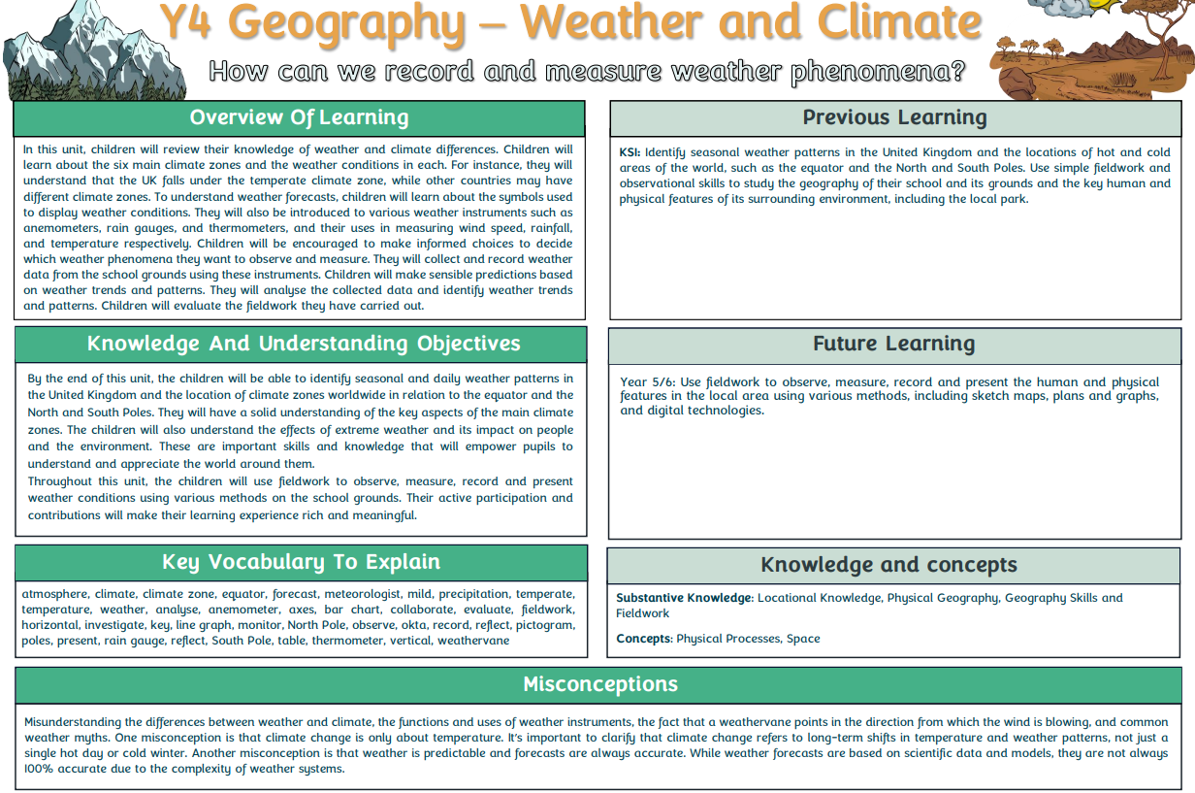
Medium Term Plan – Year 4 Spring 1 / Spring 2
What are the similarities and differences between my region and Campania, Italy?
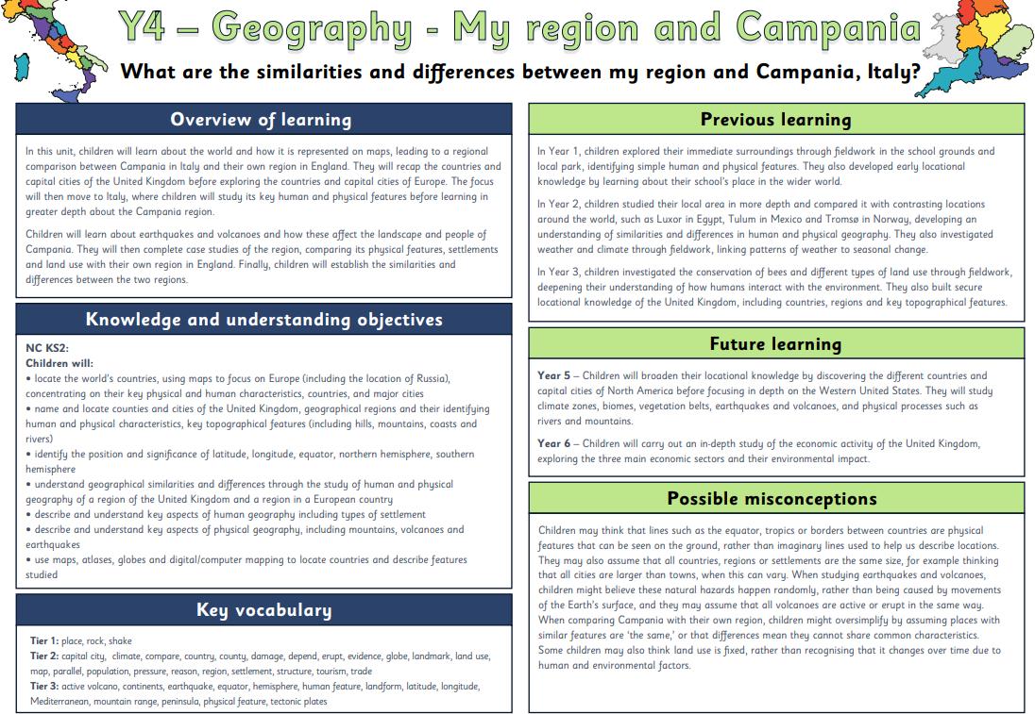
Medium Term Plan – Year 4 Summer 2
Locality Unit - Erosion on the IOW
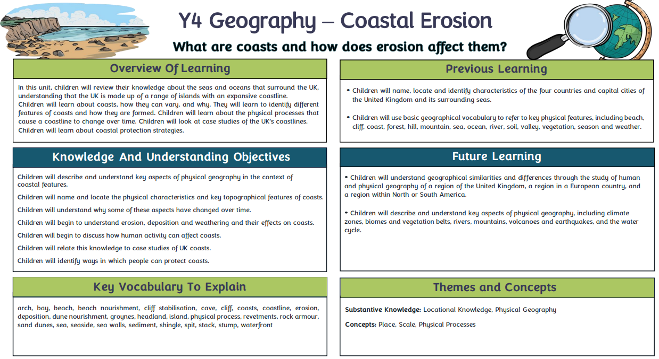
Nine Acres Primary School – Vocabulary Progression Year 5
 | Autumn 1 | Autumn 2 | Spring 1 | Spring 2 | Summer 1 | Summer 2
Year 5 |  |  |  | River, tributaries, meander, oxbow lake, mouth, estuary, floodplain, delta, river basin, source, upper course, middle course, lower course, channel, flood plain, fieldwork, data, observe, analyse, evaluate, present  Ecosystem, biomes, climate, vegetation belt, temperate, tropic of Cancer, tropic of Capricorn, longitude, latitude, species, native, precipitation, habitat, fieldwork, compass, quantitative, qualitative, grid references, northings, eastings, observe, measure, record, evaluate, present | Human feature, landform, landmark, physical feature, rural, settlement, urban, topography, biomes, continent, climate, climate zone, city, capital city, state, landmark, economy, water cycle, river, erosion, volcano, mountains, tectonic plates, vegetation belt, earthquake, metropolis, conurbation, megacity /  megalopolis, population, population density, census, GPD

Medium Term Plan – Year 5 Spring 2
Fieldwork - What are the features of my local river?
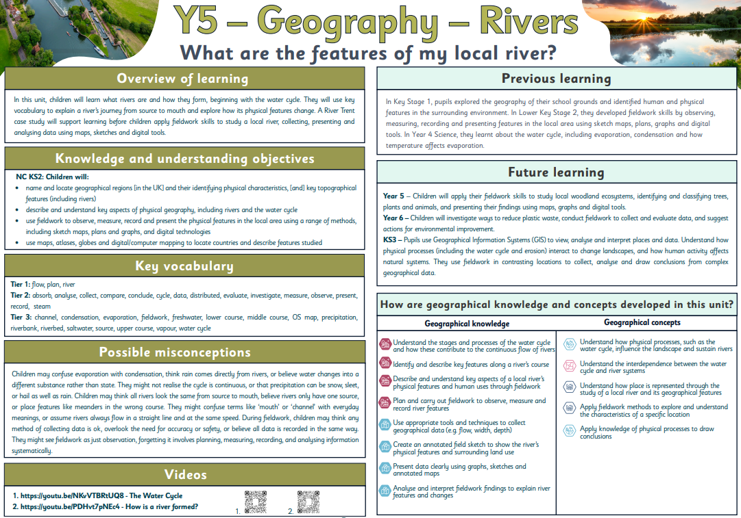
Medium Term Plan – Year 5 Spring 2
Fieldwork - What trees, plants and animals are in our local ecosystems?
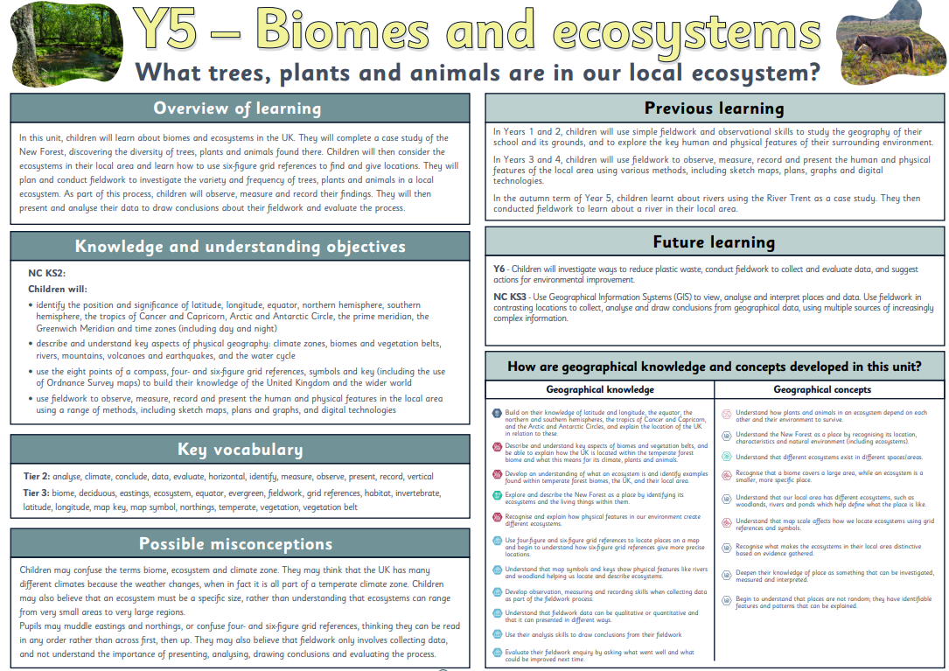
Medium Term Plan – Year 5 Summer 1
What are the similarities and differences between my region and the Western United States?
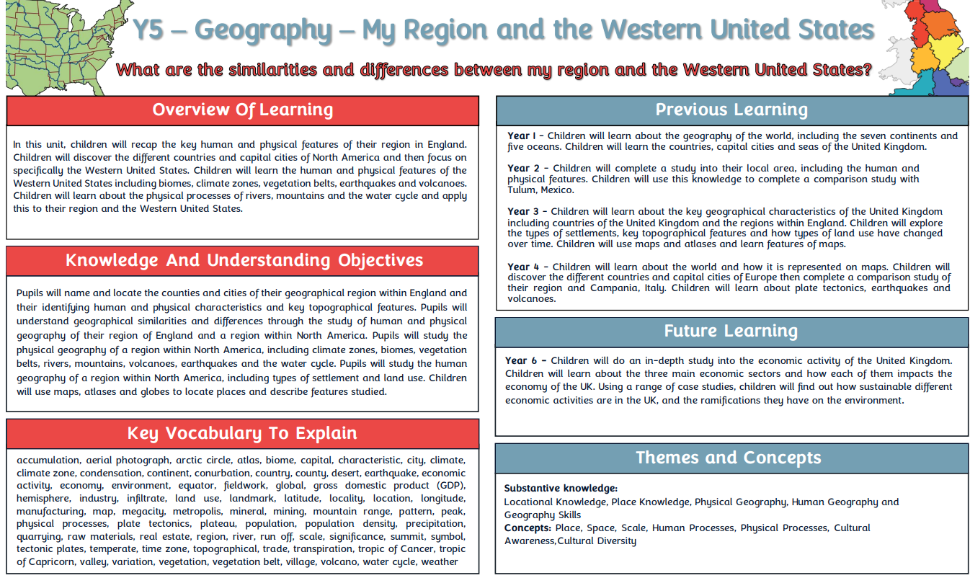
Nine Acres Primary School – Vocabulary Progression Year 6
 | Autumn 1 | Autumn 2 | Spring 1 | Spring 2 | Summer 1 | Summer 2
Year 6 | Synthetic, raw materials, extracted, refinery, durability, biodegradable, microplastics, database, fossil fuel, carbon emissions, audit, survey, implement, formulate |  |  |  |  | Agriculture, population, rural, urban, topography, tax, economy, economic activity, sector, industry, consumption, efficient, greenhouse gases, sustainable, energy, fossil fuels, export, rare earth elements, renewable energy, shortfall, disposal, refuse, reduce, reuse, recycle, sewage, waste

Medium Term Plan – Year 6 Autumn 1
What is the economic activity of the UK, and how sustainable is it?
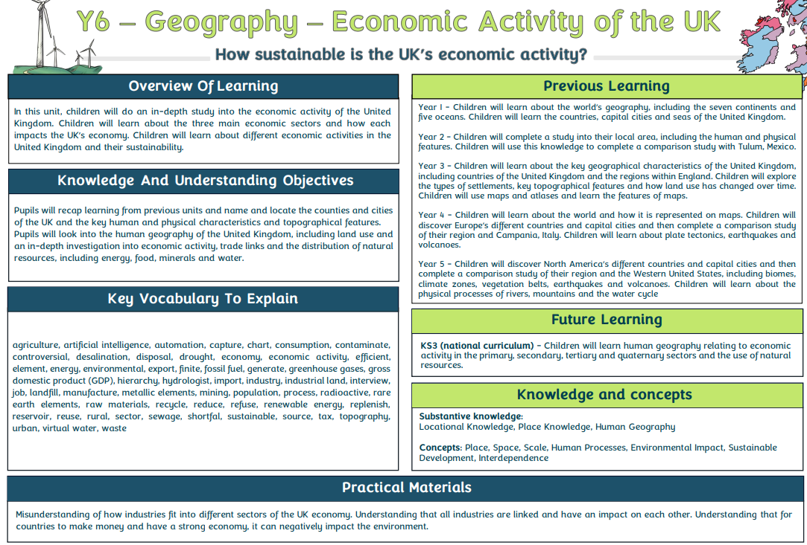
Medium Term Plan – Year 6 Summer 2
Fieldwork - How can our school reduce its plastic waste?
